**Fragment**

Исходный код проекта:

<https://github.com/verkhoumov/AndroidLabs/tree/master/Fragment>

Скриншоты экрана:

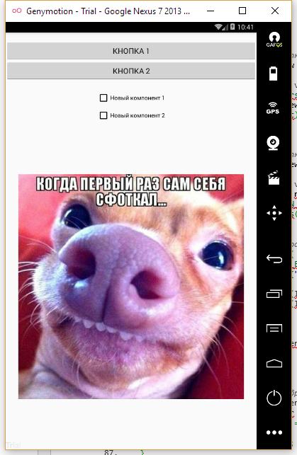

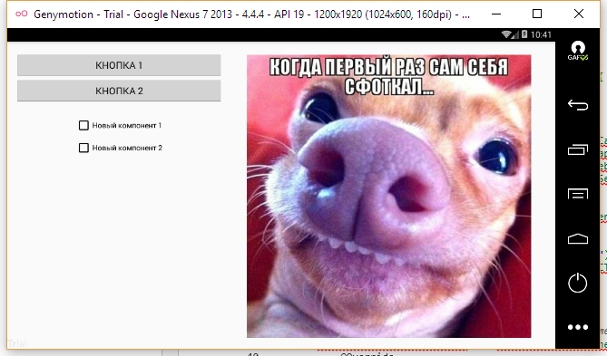

Исходный код.

MainActivity.java:

1. **package** ru.verkhoumov.fragment;
3. **import** android.support.v4.app.FragmentActivity;
4. **import** android.support.v7.app.AppCompatActivity;
5. **import** android.os.Bundle;
7. **public** **class** MainActivity **extends** FragmentActivity {
9. @Override
10. **protected** **void** onCreate(Bundle savedInstanceState) {
11. **super**.onCreate(savedInstanceState);
12. setContentView(R.layout.activity_main);
13. }
14. }

ButtonFragment.java, CheckBoxFragment.java и ImageFragment.java (аналоги):

1. **package** ru.verkhoumov.fragment;

4. **import** android.os.Bundle;
5. **import** android.support.v4.app.Fragment;
6. **import** android.view.LayoutInflater;
7. **import** android.view.View;
8. **import** android.view.ViewGroup;
10. **public** **class** ButtonFragment **extends** Fragment {
11. @Override
12. **public** View onCreateView(LayoutInflater inflater, ViewGroup container, Bundle savedInstanceState) {
13. View viewHierarchy = inflater.inflate(R.layout.button_fragment, container, **false**);
15. **return** viewHierarchy;
16. }
17. }

activity_main.xml:

1. **<?xml** version="1.0" encoding="utf-8"**?>**
2. **<LinearLayout** xmlns:android="http://schemas.android.com/apk/res/android"
3. xmlns:tools="http://schemas.android.com/tools"
4. android:layout_width="match_parent"
5. android:layout_height="match_parent"
6. android:orientation="vertical"**>**
8. **<fragment**
9. android:layout_width="match_parent"
10. android:layout_height="wrap_content"
11. android:name="ru.verkhoumov.fragment.ButtonFragment"
12. android:id="@+id/button_fragment"
13. tools:layout="@layout/button_fragment" **/>**
15. **<fragment**
16. android:layout_width="match_parent"
17. android:layout_height="wrap_content"
18. android:name="ru.verkhoumov.fragment.CheckBoxFragment"
19. android:id="@+id/checkbox_fragment"
20. tools:layout="@layout/checkbox_fragment" **/>**
22. **<fragment**
23. android:layout_width="match_parent"
24. android:layout_weight="1"
25. android:layout_height="0dp"
26. android:name="ru.verkhoumov.fragment.ImageFragment"
27. android:id="@+id/image_fragment"
28. tools:layout="@layout/image_fragment" **/>**
29. **</LinearLayout>**

activity_main.xml (land):

1. **<?xml** version="1.0" encoding="utf-8"**?>**
2. **<RelativeLayout** xmlns:android="http://schemas.android.com/apk/res/android"
3. xmlns:tools="http://schemas.android.com/tools"
4. android:layout_width="match_parent"
5. android:layout_height="match_parent"
6. android:orientation="horizontal"**>**
8. **<fragment**
9. android:layout_width="match_parent"
10. android:layout_height="wrap_content"
11. android:name="ru.verkhoumov.fragment.ButtonFragment"
12. android:id="@+id/button_fragment"
13. tools:layout="@layout/button_fragment"
14. android:layout_alignParentStart="true"
15. android:layout_marginStart="15dp"
16. android:layout_alignParentTop="true"
17. android:layout_toStartOf="@+id/image_fragment" **/>**
19. **<fragment**
20. android:layout_width="match_parent"
21. android:layout_height="wrap_content"
22. android:name="ru.verkhoumov.fragment.CheckBoxFragment"
23. android:id="@+id/checkbox_fragment"
24. tools:layout="@layout/checkbox_fragment"
25. android:layout_below="@+id/button_fragment"
26. android:layout_alignParentStart="true"
27. android:layout_toStartOf="@id/image_fragment"
28. android:layout_marginStart="15dp" **/>**
30. **<fragment**
31. android:layout_width="wrap_content"
32. android:layout_height="wrap_content"
33. android:name="ru.verkhoumov.fragment.ImageFragment"
34. android:id="@+id/image_fragment"
35. tools:layout="@layout/image_fragment"
36. android:layout_alignParentTop="true"
37. android:layout_alignParentEnd="true"
38. android:layout_marginStart="15dp"
39. android:layout_marginEnd="15dp" **/>**
40. **</RelativeLayout>**

button_fragment.xml и button_fragment.xml (land):

1. **<?xml** version="1.0" encoding="utf-8"**?>**
2. **<LinearLayout** xmlns:android="http://schemas.android.com/apk/res/android"
3. android:orientation="vertical"
4. android:layout_width="match_parent"
5. android:layout_height="match_parent"**>**
7. **<Button**
8. android:layout_width="match_parent"
9. android:layout_height="wrap_content"
10. android:text="@string/button_one"
11. android:textAllCaps="true"
12. android:id="@+id/button_one"
13. android:layout_marginTop="20dp" **/>**
15. **<Button**
16. android:layout_width="match_parent"
17. android:layout_height="wrap_content"
18. android:text="@string/button_two"
19. android:textAllCaps="true"
20. android:id="@+id/button_two" **/>**
21. **</LinearLayout>**

checkbox_fragment.xml и checkbox_fragment.xml (land):

1. **<?xml** version="1.0" encoding="utf-8"**?>**
2. **<LinearLayout** xmlns:android="http://schemas.android.com/apk/res/android"
3. android:orientation="vertical"
4. android:layout_width="match_parent"
5. android:layout_height="match_parent"**>**
7. **<CheckBox**
8. android:layout_width="wrap_content"
9. android:layout_height="wrap_content"
10. android:text="@string/checkbox_one"
11. android:id="@+id/checkbox_one"
12. android:layout_marginTop="25dp"
13. android:layout_gravity="center_horizontal" **/>**
15. **<CheckBox**
16. android:layout_width="wrap_content"
17. android:layout_height="wrap_content"
18. android:text="@string/checkbox_two"
19. android:id="@+id/checkbox_two"
20. android:layout_marginTop="10dp"
21. android:layout_gravity="center_horizontal" **/>**
22. **</LinearLayout>**

image_fragment.xml:

1. **<?xml** version="1.0" encoding="utf-8"**?>**
2. **<RelativeLayout** xmlns:android="http://schemas.android.com/apk/res/android"
3. android:orientation="vertical"
4. android:layout_width="match_parent"
5. android:layout_height="match_parent"**>**
7. **<ImageView**
8. android:layout_width="match_parent"
9. android:layout_height="wrap_content"
10. android:adjustViewBounds="true"
11. android:id="@+id/photo"
12. android:src="@drawable/photo"
13. android:layout_marginTop="25dp"
14. android:layout_marginBottom="20dp"
15. android:layout_marginStart="30dp"
16. android:layout_marginEnd="30dp" **/>**
17. **</RelativeLayout>**

image_fragment.xml (land):

1. **<?xml** version="1.0" encoding="utf-8"**?>**
2. **<RelativeLayout** xmlns:android="http://schemas.android.com/apk/res/android"
3. android:orientation="vertical"
4. android:layout_width="match_parent"
5. android:layout_height="match_parent"**>**
7. **<ImageView**
8. android:layout_width="wrap_content"
9. android:layout_height="match_parent"
10. android:adjustViewBounds="true"
11. android:id="@+id/photo"
12. android:src="@drawable/photo"
13. android:layout_marginTop="25dp"
14. android:layout_marginBottom="20dp"
15. android:layout_marginStart="30dp"
16. android:layout_marginEnd="30dp" **/>**
17. **</RelativeLayout>**

strings.xml:

1. **<resources>**
2. **<string** name="app_name"**>**Fragment**</string>**
3. **<string** name="button_one"**>**Кнопка 1**</string>**
4. **<string** name="button_two"**>**Кнопка 2**</string>**
5. **<string** name="checkbox_one"**>**Новый компонент 1**</string>**
6. **<string** name="checkbox_two"**>**Новый компонент 2**</string>**
7. **</resources>**